Muhammad Abdullah
AI Engineer
Research Report for personal project for learning
Word Count: 6542
GitHub name Muhammad-Abdullah-Jami
Contents
Abstract 4
Introduction 4
Background 5
Dataset 8
Cumulative summary of 5 and 10 years datasets 9
Methodology 10
Results and Analysis 18
Evaluation tables for 5 years dataset. 18
Evaluation tables for 10 years dataset. 22
Conclusion 26
References 26

Abstract
The study explores the application of Machine Learning ML models Long Short-Term Memory (LSTM), Random Forest Regressor, XGBoost, Support Vector Machine (SVM/SVR) for the prediction of 5 and 10 years of historical stock data of five UK banks Barclays BARC.L., Lloyds LLOY.L, HSBC HSBA.L, Standard Chartered PLC – London STAN.L and NatWest NWG.L. The models were evaluated using evaluation matrices like Mean Squared Error (MSE), Root Mean Squared Error (RMSE), Mean Absolute Error (MAE) and R² Score. The results confirm the capability of Machine Learning ML models to understand the complex stock price patterns and making predictions according to them. Among all models Random Forest Regressor outperformed every other model followed closely by LSTM while XGBoost performed moderately well and Support Vector Regressor (SVR) lagged behind most probably due to its sensitivity. The findings highlight the potential of Machine Learning model like Random Forest Regressor for the stock price prediction for both short term and long-term predictions.

Introduction
As the stock market gain popularity and the whole world witnessed its impact on the economy it was the desire of man to predict the stock price for financials gains. It was clear that mathematics and statistics can be used to predict the stock value but the stock market is a complex system affected by economy, geopolitical events, investor sentiments and a lot of other hidden factors. So Statistical linear model with moving average like ARIMA were extensively used to predict the stock price but these traditional statistical methods do not capture the complex nonlinear relationships among these factors that’s where the power of AI comes in use that is able to figure out complex relationships in these patterns and gives more accurate predictions especially when combined with technical indicators. So, Machine Learning and Deep learning found its application in stock prediction field. To predict the stock prices of major UK banks by using multiple machine learning models we needed the ethically publicly available dataset on stocks. Yfinance is opensource library that has stored stock datasets of public companies for many years so it was used with Artificial intelligence models like Long Short-Term Memory (LSTM), Random Forest, XGBoost, Support Vector Machine (SVM/SVR). When these models are trained on the dataset combined with various technical indicators such as of SMA (Simple Moving Average), EMA (Exponential Moving Average), CMA (Cumulative Moving Average) we can have a better insight of the stock data and better performing model. These models excel in capturing short term and long-term data patterns which is crucial for the stock price prediction.
The thesis project answers a vital question “How effectively Machine Learning models can predict stock price of some banks of UK?”; where key UK banks were Barclays, Lloyds, HSBC, Standard Chartered PLC – London and NatWest. These models (Long Short-Term Memory (LSTM), Random Forest, XGBoost, Support Vector Machine (SVM/SVR) ) are subjected to the comparison based on their prediction accuracy. The 5 years of historical stock data for Barclays, Lloyds, HSBC, Standard Chartered PLC – London and NatWest were available publicly at Yahoo Finance UK. Data was collected using the Yfinance Python library. After training and evaluating the models the performance of the models was astonishing. As it is clear that in machine learning and artificial intelligence the dataset itself is the backbone of the model. All the above-mentioned models were trained rigorously on five years stock dataset of the mentioned banks. For better comparison and time in hand all the Artificial Intelligence models (Long Short-Term Memory (LSTM), Random Forest, XGBoost, Support Vector Machine (SVM/SVR)) were trained again on the ten years dataset and the result was indeed better than the previously trained models on five years stock dataset.

Background
In the paper (Pham, et al., 2021) the study focused on the comparison of traditional ARIMA model with the Machine Learning model particularly XGBoost and LSTM. The study aligns with this research because it also uses LSTM and XGBoost to predict the stock price data. As both of these models are included in our work it gives better insight how these models capture the non-linearity with short term and long-term stock data. The paper (Pham, et al., 2021) used just Forex data for the prediction but it used ARIMA for base comparison for the performance and indeed the XGBoost +LSTM worked better than traditional ARIMA model at MAE, MSE, RMSE. For instance, ARIMA had the MSE of 6.114*10^-7 while the MSE of XGBoost + LSTM was 3.465*10^-7.
Table 1 Model Comparison Chart (Pham, et al., 2021):
Methods | MSE | MAE | RMSE
ARIMA | 6.114*10^-4 | 4.149*10^-4 | 7.819*10^-4
XGBoost +LSTM | 3.465*10^-7 | 3.825*10^-4 | 5.887*10^-4
Source: (Pham, et al., 2021)

The lower value of error indicates better performance. Although this approach could be generalized for other datasets but the authors focused on the Forex dataset. It is clear that the Machine Learning is revolutionizing the stock prediction field as more and more models with versatile functionality are coming. The power of XGBoost to infer data in high dimensionality and LSTM sticking to short- and long-term memory the model predictions were very realistic. Another paper (Wu, 2023) also used XGBoost model but compared it with Random Forest and Decision Tree which are ensemble base models. The key result of the paper also matches with our results which was the complexity of XGBoost model that makes it efficient is also resulting in the less performance as minor fluctuation in the data dimensions effects the performance in the bad way while the ensemble based model decision tree and random forest performed exceptionally well. Decision tree had limited accuracy while random forest spans multiple trees resulting in better accuracy as the model was selected by comparing the MSE values. The dataset of the project was comparatively small and models looked specified for a problem as the solution lacking the generic implementation but the authors were successful in implementing the model in three different data sets which are Bank of America (BAC), Chevron Corporation (CVX) and The Home Depot, Inc. (HD) so the dataset had some what similar nature like Yfinance UK datasets as the stocks data had similar variable columns of open prices, close prices, low prices, high prices and volume etc.
Table 2 Model Comparison Chart (Wu, 2023):
Stocks | Decision Tree | XGBoost | Random Forest
Bank of America (BAC) | 97.72% | 95.19% | 99.80%
Chevron Corporation (CVX) | 98.15% | 94.79% | 99.74%
The Home Depot, Inc. (HD) | 97.74% | 94.11% | 99.83%
Source: (Wu, 2023)

The paper (Wu, 2023) thoroughly studied and experimented with the three models Decision tree, random forest and XGBoost but the study lacks the use of modern deep learning models like SVM ,LSTM’s etc. incorporating the latest models would have provided the better predictions but the study remained still with comparing them with XGBoost.
In the Covid era the stocks of almost every company were unstable. The whole pandemic situation jumbled up the stocks in a way that more stable patterns became unstable after this era the traditional statistical models were unable to predict the stocks the non-linearity in the stocks was at it peak no visible patterns were found. In that era Machine Learning came into the light more than ever. People found the need of Artificial Intelligence in historical stock data to find the hidden patterns and make some relations for the prediction. For such purpose this paper (Omar, et al., 2022) discusses the historical stocks data, proposed and implemented different Artificial Intelligence models particularly Deep Neural Network DNN models on large datasets and RF model on small datasets. (Omar, et al., 2022) used hybrid approach for different types of data. The research was divided into pre-covid-19 period, covid-19 period and whole period. The dataset itself had 5077 observation points of closing price historical data ranging from year 2001 to 2021 a time period of total twenty years which is considered more than enough for the process of forecasting the prices of historical stocks. The time period is divided into pre-covid year 2001 to Feb, 2020 and covid-19 period of Feb, 2020 to Aug, 2021. As discussed the purpose of this paper was to compare the statistical models with the latest Machine Learning model, as expected the ARIMA model was unable to perform well in this scenario where there were a lot of fluctional and instability due to Covid-19 situation but the hybrid Machine Learning and Deep Neural Network DNN models like AR-RF and AR-DNN performed exceptionally well in the Karachi Stock Exchange (KSE-100). The results are explained below as the table clearly depicts the Machine Learning model performing well in era where covid made the sanitation unpredictable while ARIMA performs better on the whole data where the majority of the data points are linear. These results made it clear that Machine Learning has its application in tough and unpredictable scenarios.

Type of era | Model | MAE | RMSE | MAPE | R²
Whole Period | AR-DNN(4, 3, 10) | 2849.1945 | 3590.28 | 0.0644 | 0.9538
 | ARIMA(4, 1, 6) | 5632.8593 | 6595.2957 | 0.1313 | 0.0051
Pre Covid | AR-DNN(4, 3, 10) | 3779.8949 | 4785.5668 | 0.0877 | 0.9640
 | ARIMA(4, 1, 10) | 4617.8006 | 6016.9076 | 0.1135 | 0.098
Covid 19 | AR-RF(1) | 748.7883 | 877.6139 | 0.0158 | 0.9168
 | AR-DNN(4, 3, 10) | 3926.6735 | 4002.7292 | 0.0844 | 0.9579
 | ARIMA(3, 1, 5) |  | 1732.5614 | 0.0312 | 0.7298
Source: (Omar, et al., 2022)
These research papers sheds light on the application of different machine learning models on some historical stock data of different countries this paper (Oukhouya & El Himdi, 2023) also studies the impact of different machine learning models on the stock market of Morocco. There were 541 observations of the historical stock data between time period of December 2020 and February 2023. The research paper (Oukhouya & El Himdi, 2023) implements diverse nature of Artificial Intelligence models comprising linear, tree based and Deep Learning models. The paper also used unusual techniques like splitting the data into 9:1 mode meaning 90% for training and 10% for testing, for evaluation the usual regressor evaluation matrices like Mean Absolute Error (MAE), Mean Error (ME) Root Mean Square Error (RMSE), Mean Percentage Error(MPE), Mean Absolute Percentage Error (MAPE) and R² were used also they used Grid Search Algorithm for the process of parameter tuning for all models and in this way they were able to find best working model with most optimized parameters. The top performing model among XGBoost, LSTM, SVR and MLP was SVR with the lowest error rate MAE:3.092, RMSE:3.993 and accuracy of R² being 0.989. MLP was very close to the results so it performed second best while LSTM performed third and XGBoost was the least performing model with highest error rate among other models.
All of these papers showed the drawbacks of basic statistical models in complex scenarios and a need for Machine learning in the field of stock price prediction different comparisons of different models among stocks of different countries was crucial for the understanding of these models in unseen and versatile scenarios across the globe. These studies align properly with the study of our project of using the machine learning model for the historical stock data of banks of UK i.e. Barclays, Lloyds, HSBC, Standard Chartered PLC – London and NatWest.

Dataset
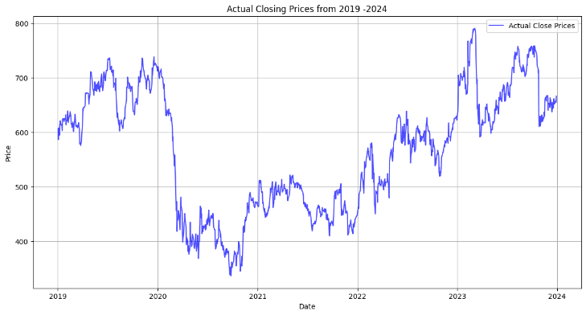
The Yfinance library was developed by Yahoo Inc. for easy extraction of stocks data before that it solely relied on API provided by Yahoo Finance. This open-source library is associated with Yahoo and American Company headquartered in Sunnyvale, California, USA. (GeeksforGeeks, n.d.). This library is ideal for downloading large amounts of financial data efficiently and research purposes. Yfinance fetches data from public platforms of respective stocks exchanges, financial market reports and official financial data feeds that are trusted sources. The data is updated most frequently as new data is collected and it is then it is made publicly available with existing Yahoo Finance API’s or it is updated in the Yfinance library ready to be processed with other libraries like NumPy and data frames like Pandas. The data was fetched from the source Yfinance (Finance, 2024) Data was stored in CSV files. Each file contains columns for Date, Open, High, Low, Close, Adjusted Close, Volume, and Technical Indicators etc. Each bank's data was around 5-10 MB, with the total dataset size near to 20-30 MB.
Figure 1 Raw Plot of stock data
The raw data was plotted using matplotlib libraries and seaborn library for certain occasions. Every ML model works efficiently on clean preprocessed data. In this regard the date time column was selected as index and missing values were checked. Although no missing values were found but proper preprocessing was done just to be sure that none raw value with any mistake find its way in the dataset. For LSTM further preprocessing (Data Normalization) was needed so MinMaxScaler was used to scale data. All datasets have five floating-point columns (float64) for stock prices and one integer column (int64) for volume. The 5-Year Dataset Covers 2019-01-02 to 2023-12-29 with datapoints around 1259 for each of historical stock data of the banks. While 10-Year Dataset Covers 2014-01-02 to 2023-12-29 time period with datapoints around 2525 entries of each stock. Below is the table representing all the details of the dataset of the historical stock data of STAN.L, LLOY.L, HSBA.L, NWG.L, and BARC.L. Key attributes listed are the dataset period, total entries, column names (Adjusted Close, Close, High, Low, Open, Volume), non-null counts for each column, and data types.

Cumulative summary of 5 and 10 years datasets
Table 1Summary of Stock Datasets for 5-Year and 10-Year Periods
Stock Symbol | Dataset Period | Entries | Columns | Non-Null Count (Per Column) | Data Types
STAN.L | 5 years | 1261 | Adj Close, Close, High, Low, Open, Volume | 1261 each | float64 (5), int64 (1)
LLOY.L | 5 years | 1259 | Adj Close, Close, High, Low, Open, Volume | 1259 each | float64 (5), int64 (1)
HSBA.L | 5 years | 1261 | Adj Close, Close, High, Low, Open, Volume | 1261 each | float64 (5), int64 (1)
NWG.L | 5 years | 1261 | Adj Close, Close, High, Low, Open, Volume | 1261 each | float64 (5), int64 (1)
STAN.L | 10 years | 2525 | Adj Close, Close, High, Low, Open, Volume | 2525 each | float64 (5), int64 (1)
BARC.L | 10 years | 2524 | Adj Close, Close, High, Low, Open, Volume | 2524 each | float64 (5), int64 (1)
LLOY.L | 10 years | 2523 | Adj Close, Close, High, Low, Open, Volume | 2523 each | float64 (5), int64 (1)
HSBA.L | 10 years | 2525 | Adj Close, Close, High, Low, Open, Volume | 2525 each | float64 (5), int64 (1)
NWG.L | 10 years | 2525 | Adj Close, Close, High, Low, Open, Volume | 2525 each | float64 (5), int64 (1)

Methodology
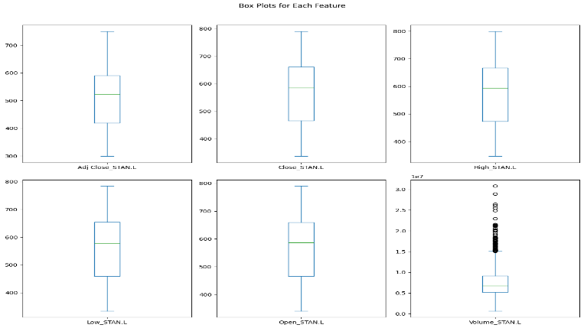
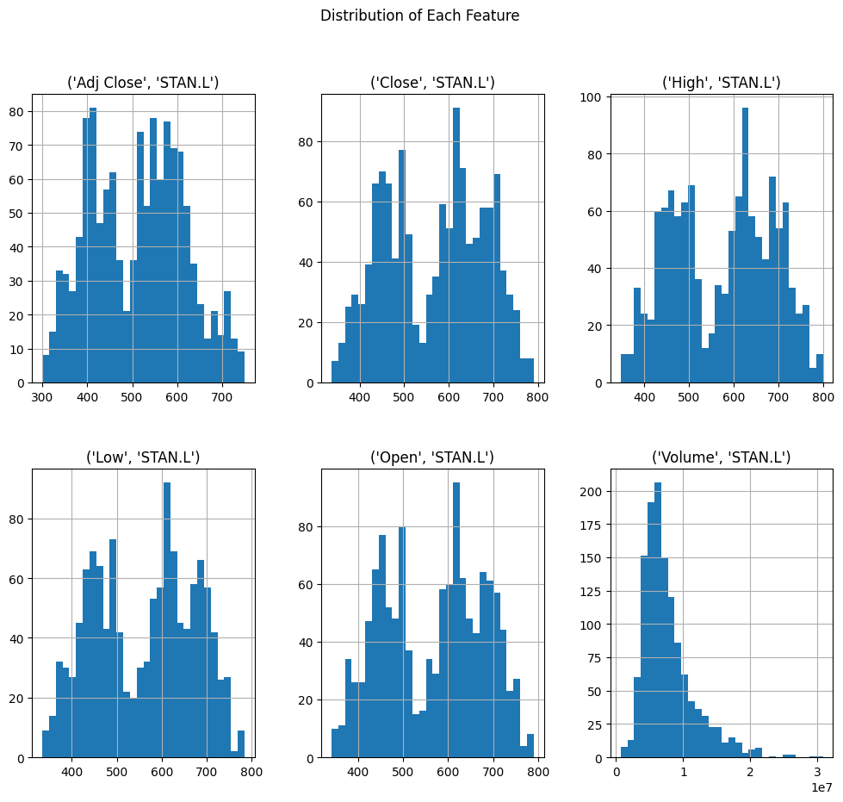
For EDA different NumPy functions were used to proper elaborate data then preprocessing was applied for the purpose of setting up data for plotting charts for further in-depth EDA. Feature distributions plots, line plots, box plots were also used to visualize the stock price trend below is the feature distribution of each attribute of the dataset showing uniform distribution. The columns ‘Adj close’, ‘close’, ‘high’ ‘low’, ‘open’ have uniformly distributed distribution of instances only the ‘Volume’ of the data is skewed meaning the data points of volume of historical stock data has a non-uniform range such that most of the stock data ranges in a special range while there are more than usual big volume of stock data that act as outliers. Similarly the box plots were made and it also represents outliers in
Figure 2 Box plot distribution
the volume of historical stock dataset for each bank Barclays BARC.L., Lloyds LLOY.L, HSBC HSBA.L, Standard Chartered PLC – London STAN.L and NatWest NWG.L.
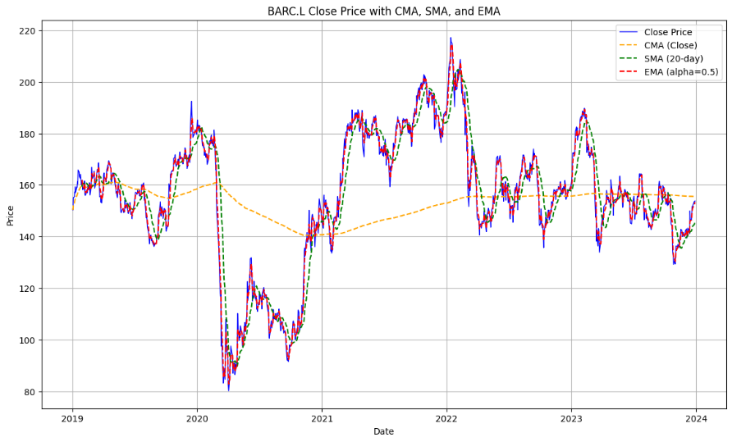
Feature Engineering is statistical calculation of data that creates new relatable attributes by analyzing the existing features and applying statistical functions such that the resulting attributes are feature itself to the existing dataset and these attributes are better represent the underlying pattern in the data. SMA (Simple Moving Average), EMA (Exponential Moving Average), CMA (Cumulative Moving Average) plots were merged with the original 5 years and 10 years of the historical stock plot. These technical indicators gave useful insights about the general up or down stock trend. The new columns that have the data of SMA (Simple Moving Average), EMA (Exponential Moving Average), CMA (Cumulative Moving Average) were also effective in model training as they acted as additional features of the stock data. SMA (Simple Moving Average) calculates the average price of the stock over specific number of period in the thesis project the value of window size was set to 20 days to smooth out the fluctuating short term trend. The graph was plotted using the matplotlib library of python and the graph lines was represented by dotted green line. EMA (Exponential Moving Average) is similar to the SMA (Simple Moving Average) but it adds more weightage to the recent datapoints meaning that the EMA (Exponential Moving Average) is more sensitive to the new and recent data so it visualize the recent stock trends by utilizing its weight creating a momentum of the historical stock prices. CMA (Cumulative Moving Average) is the average of all the points so it flat outs most of the small fluctuation in the graph giving a general more precise long term and overviewed trend of a graph.
Figure 3 Feature Engineering 5 years

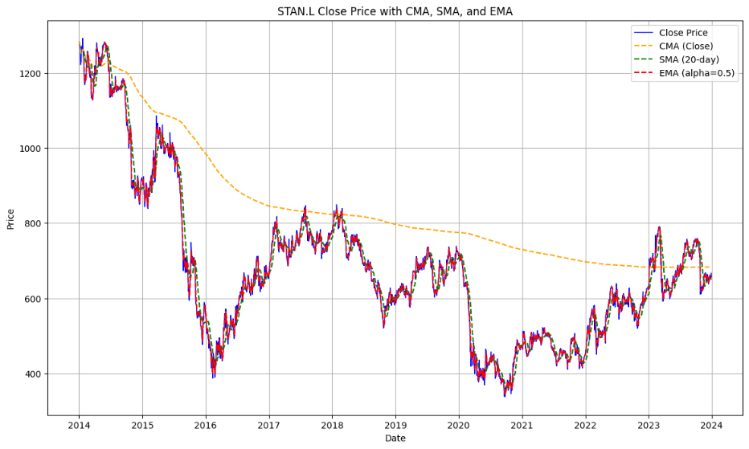
The result of the feature engineering was that not only it gave better insights of the stock trend but it also enriched the existing data set with meaningful and relatable datapoints that proved very beneficial to the training of models for both 5 years and 10 years of the dataset.
Figure 4 Feature Engineering 10 years
As we know that the whole purpose of the project was to implement the Machine Learning Models to the stock data so model functions were created. The functions were made as simple as possible so that the functions can be called with different parameters and it will train and evaluate the whole model printing different errors like of Mean Squared Error (MSE), Root Mean Squared Error (RMSE), Mean Absolute Error (MAE), R2_Score. These functions kept an eye on model training evaluating the predictions side by side as they were made from the test data and plotted how close function is predicting compared to the original data. The fluctuation in the lines is due to the reason the data was properly shuffled as we used Sciket-learn test train function to split the data to testing and training portions. For the future price predictions that will be continuous to existing five years data we needed to create index and other details so that the plot should result in more interpretable and detailed for the predictions. After the desired results were produced, the saved model was used to predict the stock price. Furthermore, the model performance on the bases of error rate of the test data was calculated so that a general idea can be obtained which model is giving most accurate predictions. We found out that the LSTM model is performing much better than another model like SVR. The proper reason is its architecture which allows LSTM to use the memory cells while training, the time-step was set to sixty (60) days so that the model can look back and analyses the sixty days trend while making the prediction. The model was evaluated on the bases of Mean Squared Error (MSE), Root Mean Squared Error (RMSE), Mean Absolute Error (MAE), R2_Score or Loss Function. As it is a regression problem and evaluation method like accuracy, precision, recall, f1_score and confusion matrix cannot be used. To evaluate the regression models error rate was calculated and reduced with several experimentation with the hyper parameter tuning; for instance, the hyperparameter tuning resulted in the better model evaluations on Standard Chartered PLC – London (STAN.L) stock data.
The stock data of five different banks was subjected to training and prediction of 4 different models and doing it again with parameter tuning. This would made a huge ipnyb notebook which would be very difficult to understand. This challenge was addressed by making model functions which was a challenge itself as we needed a proper balance between the generalization of the model function and its feasibility to integrate dataset and hyper parameters as its function parameters. Limited time also prevented doing further experimentation and usage of advance model like transformers but this project successfully implemented other models for stock price predictions of UK banks. After the implementation of five years data of historical stock prices the training and experimenting above mentioned models on 10 years of stock data of every five banks Barclays BARC.L., Lloyds LLOY.L, HSBC HSBA.L, Standard Chartered PLC – London STAN.L and NatWest NWG.L.
At the end of the model implementations following objectives were achieved and they will be reviewed in detail later.
- Trained Machine Learning/Deep Learning models on ethical historical stock price data
- Calculated technical indicators for proper feature engineering of data
- Evaluated models based on various error rate
- One year future continuous stocks predictions
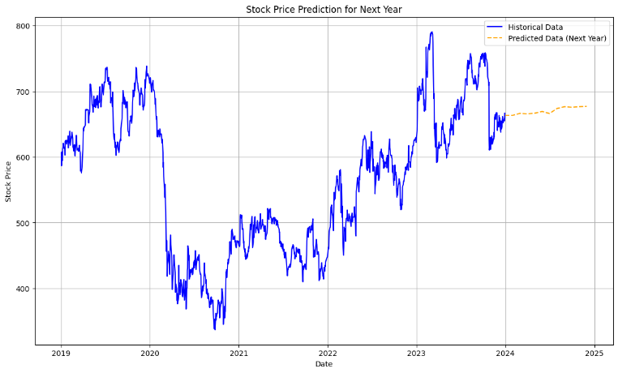
Random Forest Regressor is a tree-based ensemble model that excels in regression tasks, such as predicting stock prices. It aggregates multiple decision trees to reduce overfitting and improve accuracy. This model is great for capturing non-linear relationships in stock data and for handling high dimensional data such as technical indicators combined with stock prices. The model was trained and tested on various hyperparameters after the model was trained the y_pred labels were stored and used to compare with the original labels for the performance measurement. For this purpose, Sklearn libraries like mean_squared_error, r2_score and mean_absolute_error were used and these evaluations were calculated. In the Mean Squared Error (MSE), Root Mean Squared Error (RMSE), Mean Absolute Error (MAE) the smaller is the value the more perfect is model performing. The Mean Squared Error (MSE) is the average difference between the actual and predicted values and it is calculated by the formula MSE=1/n ​i=1∑n​(yi​−y^​i​)2. The Mean Squared Error (MSE) value of model Random Forest Regressor was 56.6155 , as the square of the values gives different units so we also use another performance metrics named as Root Mean Squared Error (RMSE) which is the square root of Mean Squared Error (MSE) so that the expanded values due to the square comes to the near original state for better understanding of the error rate. The Root Mean Squared Error (RMSE) is calculated by using the formula RMSE= SQRT (1/n ​i=1∑n​(yi​−y^​i​)2​) and the value of Root Mean Squared Error (RMSE) was 7.5243. The other performance metrics is Mean Absolute Error (MAE) which measures the average magnitude of predictions errors ignoring the directions, calculation formula for this is MAE=1/n ​i=1∑n​∣yi​−y^​i​∣ . The Mean Absolute Error (MAE) of the model was 5.1919 . For these three performance evaluation matrices Mean Squared Error (MSE), Root Mean Squared Error (RMSE), Mean Absolute Error (MAE) the numerical values should be as small as possible, the smaller the values are the better is the performance of the model. Another performance metrics is R2_score, the R² Score or also known as the Coefficient of Determination is also a statistical measurement process for regression models. It represents the variance of the proportion of all the target variables predicted. The formula for R² Score calculation is R2=1− (∑(yi−y^i)^2 \ ( ∑(yi​−y)^2 ). Its values range from -∞ to 1 while the R² Score values of 1 represents the model perfectly predicts the target variables and R² Score values of 0 represents the model is working just b predicting the mean of target variables. While the negative R² Score value represents the model is predicting worse than mean values. So, in simple the value should be near to 1. The R² Score of the model was 0.9953. Which represents high variance and excellent model performance. Although this is a regression problem but I tried to implement a Random Forest Classifier to judge if the classifier works on this problem but the result was unsatisfactory as expected the evaluations were Accuracy: 0.54, F1 Score: 0.54, Precision: 0.51, Recall: 0.57 which is more like a guess for stocks to go up and down and this 54% accuracy is not reliable. After I confirmed that the Random Forest Classifier underperformed, I carry on implementing other regression models.
Figure 5 Price Prediction
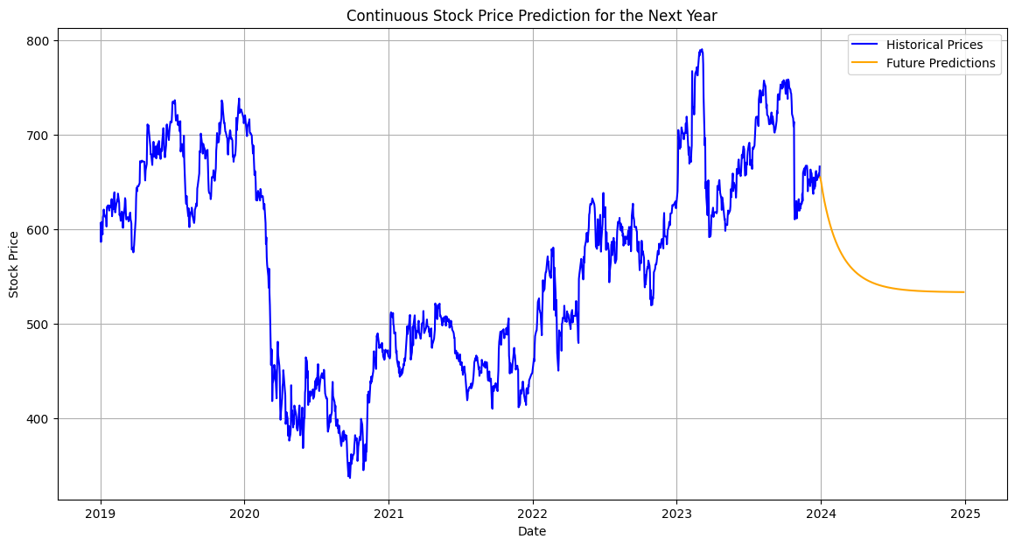
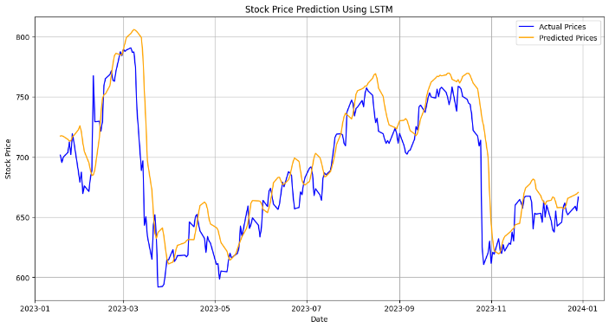
LSTM networks are designed to handle sequential data, such as time series, which is exactly what stock prices represent. LSTMs can capture both short-term and long-term dependencies in data, which makes them ideal for predicting stock price movements over time. LSTM is best model for capturing patterns in stock price trends over a long period (such as weeks, months, or years) because it solves the vanishing gradient problem that arises in traditional neural networks when processing time series data. The model was trained and tested on various hyperparameters after the model was trained the y_pred labels were stored and used to compare with the original labels for the performance measurement. For this purpose, Sklearn libraries like mean_squared_error, r2_score and mean_absolute_error were used and these evaluations were calculated. In the Mean Squared Error (MSE), Root Mean Squared Error (RMSE), Mean Absolute Error (MAE) the smaller is the value the more perfect is model performing. The Mean Squared Error (MSE) is the average difference between the actual and predicted values and it is calculated by the formula MSE=1/n ​i=1∑n​(yi​−y^​i​)2. The Mean Squared Error (MSE) value of model Long Short-Term Memory (LSTM) was 282.9097, as the square of the values gives different units so we also use another performance metrics named as Root Mean Squared Error (RMSE) which is the square root of Mean Squared Error (MSE) so that the expanded values due to the square comes to the near original state for better understanding of the error rate. The Root Mean Squared Error (RMSE) is calculated by using the formula RMSE= SQRT (1/n ​i=1∑n​(yi​−y^​i​)2​) and the value of Root Mean Squared Error (RMSE) was 16.8199. The other performance metrics is Mean Absolute Error (MAE) which measures the average magnitude of predictions errors ignoring the directions, calculation formula for this is MAE=1/n ​i=1∑n​∣yi​−y^​i​∣ . The Mean Absolute Error (MAE) of the model was 12.1130. For these three performance evaluation matrices Mean Squared Error (MSE), Root Mean Squared Error (RMSE), Mean Absolute Error (MAE) the numerical values should be as small as possible, the smaller the values are the better is the performance of the model. Another performance metrics is R2_score, the R² Score or also known as the Coefficient of Determination is also a statistical measurement process for regression models. It represents the variance of the proportion of all the target variables predicted. The formula for R² Score calculation is R2=1− (∑(yi−y^i)^2 \ ( ∑(yi​−y)^2 ). Its values range from -∞ to 1 while the R² Score values of 1 represents the model perfectly predicts the target variables and R² Score values of 0 represents the model is working just b predicting the mean of target variables. While the negative R² Score value represents the model is predicting worse than mean values. So, in simple the value should be near to 1. The R² Score of the model was 0.8927. Which represents high variance and excellent model performance.
Figure 6 Price Prediction
Figure 7 Model training process

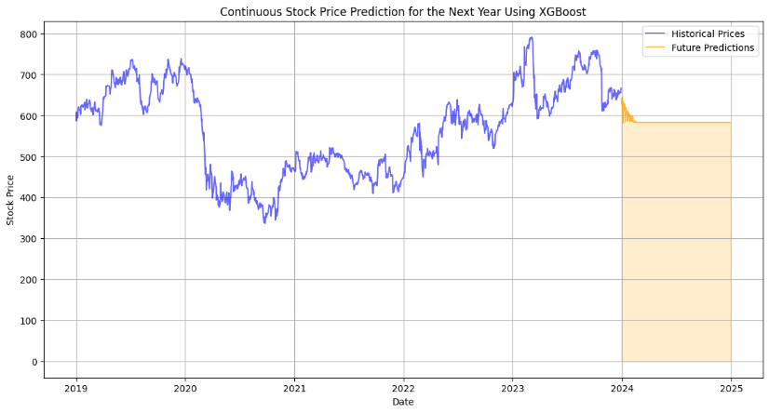
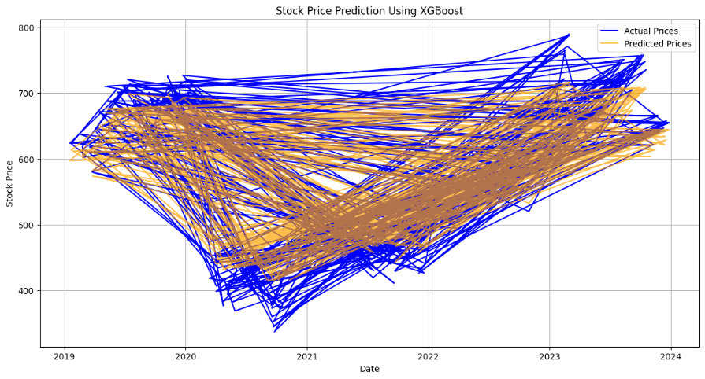
XGBoost is a highly efficient and scalable machine learning algorithm, known for its ability to handle large datasets quickly. It is built on the concept of boosting, where each subsequent model corrects the errors of the previous ones. XGBoost is especially effective in capturing complex patterns and interactions in stock price data and is often used in competitions for predictive tasks because of its high accuracy and performance. The model was trained and tested on various hyperparameters after the model was trained the y_pred labels were stored and used to compare with the original labels for the performance measurement. For this purpose, Sklearn libraries like mean_squared_error, r2_score and mean_absolute_error were used and these evaluations were calculated. In the Mean Squared Error (MSE), Root Mean Squared Error (RMSE), Mean Absolute Error (MAE) the smaller is the value the more perfect is model performing. The Mean Squared Error (MSE) is the average difference between the actual and predicted values and it is calculated by the formula MSE=1/n ​i=1∑n​(yi​−y^​i​)2. The Mean Squared Error (MSE) value of model XGBoost was 858.4905, as the square of the values gives different units so we also use another performance metrics named as Root Mean Squared Error (RMSE) which is the square root of Mean Squared Error (MSE) so that the expanded values due to the square comes to the near original state for better understanding of the error rate. The Root Mean Squared Error (RMSE) is calculated by using the formula RMSE= SQRT (1/n ​i=1∑n​(yi​−y^​i​)2​) and the value of Root Mean Squared Error (RMSE) was 29.3000. The other performance metrics is Mean Absolute Error (MAE) which measures the average magnitude of predictions errors ignoring the directions, calculation formula for this is MAE=1/n ​i=1∑n​∣yi​−y^​i​∣ . The Mean Absolute Error (MAE) of the model was 24.6585. For these three performance evaluation matrices Mean Squared Error (MSE), Root Mean Squared Error (RMSE), Mean Absolute Error (MAE) the numerical values should be as small as possible, the smaller the values are the better is the performance of the model. Another performance metrics is R2_score, the R² Score or also known as the Coefficient of Determination is also a statistical measurement process for regression models. It represents the variance of the proportion of all the target variables predicted. The formula for R² Score calculation is R2=1− (∑(yi−y^i)^2 \ ( ∑(yi​−y)^2 ). Its values range from -∞ to 1 while the R² Score values of 1 represents the model perfectly predicts the target variables and R² Score values of 0 represents the model is working just b predicting the mean of target variables. While the negative R² Score value represents the model is predicting worse than mean values. So, in simple the value should be near to 1. The R² Score of the model was 0.9332. Which represents high variance and excellent model performance.
Figure 8 Price Prediction
Figure 9 Model Training process
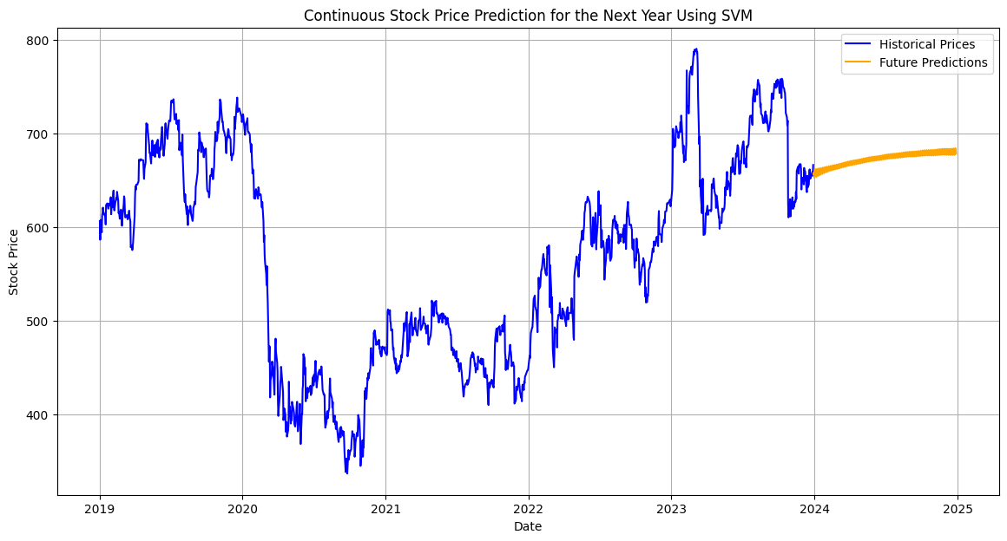
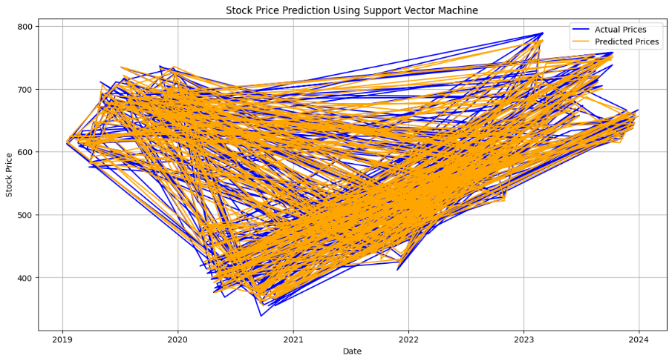
Support Vector Machine (SVM)for regression is Support Vector Regressor SVR which is a robust model that performs well in both classification and regression tasks. It is particularly effective in cases where the dataset is high-dimensional and contains non-linear patterns. SVR is great for stock prediction where we want to classify price movements (up/down) or forecast trends. It is known for its generalization performance in a variety of tasks. The model was trained and tested on various hyperparameters after the model was trained the y_pred labels were stored and used to compare with the original labels for the performance measurement. For this purpose, Sklearn libraries like mean_squared_error, r2_score and mean_absolute_error were used and these evaluations were calculated. In the Mean Squared Error (MSE), Root Mean Squared Error (RMSE), Mean Absolute Error (MAE) the smaller is the value the more perfect is model performing. The Mean Squared Error (MSE) is the average difference between the actual and predicted values and it is calculated by the formula MSE=1/n ​i=1∑n​(yi​−y^​i​)2. The Mean Squared Error (MSE) value of model Support Vector Regressor SVR was 161.64, as the square of the values gives different units so we also use another performance metrics named as Root Mean Squared Error (RMSE) which is the square root of Mean Squared Error (MSE) so that the expanded values due to the square comes to the near original state for better understanding of the error rate. The Root Mean Squared Error (RMSE) is calculated by using the formula RMSE= SQRT (1/n ​i=1∑n​(yi​−y^​i​)2​) and the value of Root Mean Squared Error (RMSE) was 12.71. The other performance metrics is Mean Absolute Error (MAE) which measures the average magnitude of predictions errors ignoring the directions, calculation formula for this is MAE=1/n ​i=1∑n​∣yi​−y^​i​∣ . The Mean Absolute Error (MAE) of the model was 8.98. For these three performance evaluation matrices Mean Squared Error (MSE), Root Mean Squared Error (RMSE), Mean Absolute Error (MAE) the numerical values should be as small as possible, the smaller the values are the better is the performance of the model. Another performance metrics is R2_score, the R² Score or also known as the Coefficient of Determination is also a statistical measurement process for regression models. It represents the variance of the proportion of all the target variables predicted. The formula for R² Score calculation is R2=1− (∑(yi−y^i)^2 \ ( ∑(yi​−y)^2 ). Its values range from -∞ to 1 while the R² Score values of 1 represents the model perfectly predicts the target variables and R² Score values of 0 represents the model is working just b predicting the mean of target variables. While the negative R² Score value represents the model is predicting worse than mean values. So, in simple the value should be near to 1. The R² Score of the model was 0.99. Which represents high variance and excellent model performance.
Figure 10 Price Prediction
Figure 11 Model Training process

Results and Analysis
Four Machine Learning ML Models Long Short-Term Memory (LSTM), Random Forest Regressor, XGBoost, Support Vector Machine (SVM/SVR) were implemented on historical stock data of five UK Banks Barclays BARC.L., Lloyds LLOY.L, HSBC HSBA.L, Standard Chartered PLC – London STAN.L and NatWest NWG.L. twice, once with five years of historical stock data and second time with the ten years of historical stock data. Following is the table which contains the stocks names and duration like five or ten years, model names with parameters tuned, the evaluation metrics of Mean Squared Error (MSE), Root Mean Squared Error (RMSE), Mean Absolute Error (MAE) and R² Score and in the end prediction simplified from graph as up or down.

Evaluation tables for 5 years dataset.

Stock Name | Model Name | Parameters Tuned | MSE | RMSE | MAE | R² Score | Prediction (Up/Down)
Standard Chartered | Random Forest | estim=100, test_size=0.2 | 56.6155 | 7.5243 | 5.1919 | 0.9953 | up
 | LSTM | epochs=50, batch_size=32, optim='adam', los='mean_squared_error' | 510.0090 | 22.5834 | 16.4767 | 0.8067 | Up
 | LSTM | epochs=100, batch_size=40, optim='adam', | 282.9097 | 16.8199 | 12.1131 | 0.8928 | down
 | XGBoost | testsiz=0.3, n_esti=150, learn_rate=0.01, max_dep=5 | 858.4905 | 29.3000 | 24.6585 | 0.9332 | down
 | XGBoost | testsiz=0.2, n_esti=100, learn_rate=0.1, max_dep=5 | 146.0739 | 12.0861 | 8.8400 | 0.9888 | Up
 | SVR | testsiz=0.3, c=100, epi=0.1 | 161.6400 | 12.7100 | 8.9800 | 0.9900 | Up
 | SVR | testsiz=0.2, c=150, epi=0.01 | 172.7200 | 13.1400 | 9.1400 | 0.9900 | up
Barclays | Random Forest | estim=100, test_size=0.2 | 56.6155 | 7.5243 | 5.1919 | 0.9953 | up
 | LSTM | epochs=50, batch_size=32, optim='adam', los='mean_squared_error' | 480.6662 | 21.9241 | 15.6514 | 0.8178 | up
 | LSTM | epochs=100, batch_size=40, optim='adam', los='mean_squared_error' | 12.0084 | 3.4653 | 2.5622 | 0.9320 | up
 | XGBoost | testsiz=0.3, n_esti=150, learn_rate=0.01, max_dep=5 | 58.9753 | 7.6795 | 5.7181 | 0.9207 | up
 | XGBoost | testsiz=0.2, n_esti=100, learn_rate=0.1, max_dep=5 | 16.4368 | 4.0542 | 2.9267 | 0.9767 | up
 | SVR | testsiz=0.3, c=100, epi=0.1 | 13.5300 | 3.6800 | 2.5200 | 0.9800 | down
 | SVR | testsiz=0.2, c=150, epi=0.01 | 14.9100 | 3.8600 | 2.6000 | 0.9800 | down
Lloyds | Random Forest | estim=100, test_size=0.2 | 0.2755 | 0.5249 | 0.3911 | 0.9970 | up
 | LSTM | epochs=50, batch_size=32, optim='adam', los='mean_squared_error' | 0.9521 | 0.9757 | 0.7555 | 0.9205 | down
 | LSTM | epochs=100, batch_size=40, optim='adam', los='mean_squared_error' | 0.7434 | 0.8622 | 0.6602 | 0.9379 | up
 | XGBoost | testsiz=0.3, n_esti=150, learn_rate=0.01, max_dep=5 | 6.1615 | 2.4822 | 1.8190 | 0.9311 | up
 | XGBoost | testsiz=0.2, n_esti=100, learn_rate=0.1, max_dep=5 | 1.3236 | 1.1505 | 0.8163 | 0.9864 | down
 | SVR | testsiz=0.3, c=100, epi=0.1 | 1.0800 | 1.0400 | 0.7100 | 0.9900 | down
 | SVR | testsiz=0.2, c=150, epi=0.01 | 1.1400 | 1.0700 | 0.7200 | 0.9900 | up

Stock Name | Model Name | Parameters Tuned | MSE | RMSE | MAE | R² Score | Prediction (Up/Down)
HSBC | Random Forest | estim=100, test_size=0.2 | 25.7161 | 5.0711 | 3.6581 | 0.9975 | up
 | LSTM | epochs=50, batch_size=32, optim='adam', los='mean_squared_error' | 228.7168 | 15.1234 | 12.8671 | 0.6569 | down
 | LSTM | epochs=100, batch_size=40, optim='adam', los='mean_squared_error' | 138.9271 | 11.7867 | 9.6257 | 0.7916 | down
 | XGBoost | testsiz=0.3, n_esti=150, learn_rate=0.01, max_dep=5 | 677.4033 | 26.0270 | 22.1292 | 0.9352 | down
 | XGBoost | testsiz=0.2, n_esti=100, learn_rate=0.1, max_dep=5 | 87.0951 | 9.3325 | 6.7052 | 0.9916 | down
 | SVR | testsiz=0.3, c=100, epi=0.1 | 86.2500 | 9.2900 | .4300 | 0.9900 | up
 | SVR | testsiz=0.2, c=150, epi=0.01 | 101.2500 | 10.0600 | 6.9200 | 0.9900 | up

Stock Name | Model Name | Parameters Tuned | MSE | RMSE | MAE | R² Score | Prediction (Up/Down)
NatWest | Random Forest | estim=100, test_size=0.2 | 8.8080 | 2.9678 | 2.1489 | 0.9963 | down
 | LSTM | epochs=50, batch_size=32, optim='adam', los='mean_squared_error' | 45.4926 | 6.7448 | 5.1423 | 0.9526 | up
 | LSTM | epochs=100, batch_size=40, optim='adam', los='mean_squared_error' | 42.9375 | 6.5527 | 5.2401 | 0.9553 | down
 | XGBoost | testsiz=0.3, n_esti=150, learn_rate=0.01, max_dep=5 | 155.4064 | 12.4662 | 9.2860 | 0.9350 | down
 | XGBoost | testsiz=0.2, n_esti=100, learn_rate=0.1, max_dep=5 | 24.7409 | 4.9740 | 3.6678 | 0.9892 | down
 | SVR | testsiz=0.3, c=100, epi=0.1 | 23.1000 | 4.8100 | 3.4400 | 0.9900 | down
 | SVR | testsiz=0.2, c=150, epi=0.01 | 25.4200 | 5.0400 | 3.5300 | 0.9900 | down

Evaluation tables for 10 years dataset.

Stock Name | Model Name | Parameters Tuned | MSE | RMSE | MAE | R² Score | Prediction (Up/Down)
Standard Chartered | Random Forest | estim=100, test_size=0.2 | 67.2207 | 8.1988 | 5.8423 | 0.9983 | up
 | LSTM | epochs=50, batch_size=32, optim='adam', los='mean_squared_error' | 335.4426 | 18.3151 | 12.9550 | 0.9408 | down
 | LSTM | epochs=100, batch_size=40, optim='adam', los='mean_squared_error' | 222.4012 | 14.9131 | 10.3076 | 0.9607 | down
 | XGBoost | testsiz=0.3, n_esti=150, learn_rate=0.01, max_dep=5 | 2376.4050 | 48.7484 | 37.7260 | 0.9416 | down
 | XGBoost | testsiz=0.2, n_esti=100, learn_rate=0.1, max_dep=5 | 185.3100 | 13.6100 | 9.4900 | 1.0000 | up
 | SVR | testsiz=0.3, c=100, epi=0.1 | 185.3100 | 13.6100 | 9.4900 | 1.0000 | down
 | SVR | testsiz=0.2, c=150, epi=0.01 | 166.4800 | 12.9000 | 9.2000 | 1.0000 | down

Stock Name | Model Name | Parameters Tuned | MSE | RMSE | MAE | R² Score | Prediction (Up/Down)
Barclays | Random Forest | estim=100, test_size=0.2 | 4.5161 | 2.1251 | 1.5507 | 0.9973 | up
 | LSTM | epochs=50, batch_size=32, optim='adam', los='mean_squared_error' | 24.0422 | 4.9033 | 3.5817 | 0.9076 | up
 | LSTM | epochs=100, batch_size=40, optim='adam', los='mean_squared_error' | 15.2552 | 3.9058 | 3.0630 | 0.9414 | down
 | XGBoost | testsiz=0.3, n_esti=150, learn_rate=0.01, max_dep=5 | 103.8916 | 10.1927 | 7.9634 | 0.9399 | up
 | XGBoost | testsiz=0.2, n_esti=100, learn_rate=0.1, max_dep=5 | 15.9254 | 3.9907 | 2.7516 | 0.9903 | up
 | SVR | testsiz=0.3, c=100, epi=0.1 | 13.7900 | 3.7100 | 2.5700 | 0.9900 | up
 | SVR | testsiz=0.2, c=150, epi=0.01 | 15.3000 | 3.9100 | 2.6800 | 0.9900 | up

Stock Name | Model Name | Parameters Tuned | MSE | RMSE | MAE | R² Score | Prediction (Up/Down)
Lloyds | Random Forest | estim=100, test_size=0.2 | 0.3554 | 0.5961 | 0.4153 | 0.9983 | up
 | LSTM | epochs=50, batch_size=32, optim='adam', los='mean_squared_error' | 1.3163 | 1.1473 | 0.8412 | 0.8830 | up
 | LSTM | epochs=100, batch_size=40, optim='adam', los='mean_squared_error' | 1.1497 | 1.0723 | 0.8003 | 0.8978 | up
 | XGBoost | testsiz=0.3, n_esti=150, learn_rate=0.01, max_dep=5 | 12.2137 | 3.4948 | 2.8596 | 0.9438 | up
 | XGBoost | testsiz=0.2, n_esti=100, learn_rate=0.1, max_dep=5 | 1.5745 | 1.2548 | 0.7678 | 0.9924 | up
 | SVR | testsiz=0.3, c=100, epi=0.1 | 1.3000 | 1.1400 | 0.7200 | 0.9900 | up
 | SVR | testsiz=0.2, c=150, epi=0.01 | 1.3700 | 1.1700 | 0.7200 | 0.9900 | up

Stock Name | Model Name | Parameters Tuned | MSE | RMSE | MAE | R² Score | Prediction (Up/Down)
HSBC | Random Forest | estim=100, test_size=0.2 | 24.8004 | 4.9800 | 3.6791 | 0.9979 | up
 | LSTM | epochs=50, batch_size=32, optim='adam', los='mean_squared_error' | 178.2328 | 13.3504 | 9.6456 | 0.9398 | up
 | LSTM | epochs=100, batch_size=40, optim='adam', los='mean_squared_error' | 114.4858 | 10.6998 | 7.9970 | 0.9613 | down
 | XGBoost | testsiz=0.3, n_esti=150, learn_rate=0.01, max_dep=5 | 726.8374 | 26.9599 | 21.9333 | 0.9403 | down
 | XGBoost | testsiz=0.2, n_esti=100, learn_rate=0.1, max_dep=5 | 69.1166 | 8.3136 | 5.9635 | 0.9945 | down
 | SVR | testsiz=0.3, c=100, epi=0.1 | 70.1400 | 8.3800 | 5.9900 | 0.9900 | down
 | SVR | testsiz=0.2, c=150, epi=0.01 | 69.1700 | 8.3200 | 5.9200 | 0.9900 | down

Stock Name | Model Name | Parameters Tuned | MSE | RMSE | MAE | R² Score | Prediction (Up/Down)
NatWest | Random Forest | estim=100, test_size=0.2 | 8.0669 | 2.8402 | 2.1244 | 0.9983 | down
 | LSTM | epochs=50, batch_size=32, optim='adam', los='mean_squared_error' | 45.3831 | 6.7367 | 5.3301 | 0.9280 | down
 | LSTM | epochs=100, batch_size=40, optim='adam', los='mean_squared_error' | 59.6217 | 7.7215 | 5.9950 | 0.9054 | up
 | XGBoost | testsiz=0.3, n_esti=150, learn_rate=0.01, max_dep=5 | 292.7265 | 17.1093 | 12.8453 | 0.9428 | up
 | XGBoost | testsiz=0.2, n_esti=100, learn_rate=0.1, max_dep=5 | 33.8289 | 5.8163 | 4.0684 | 0.9934 | down
 | SVR | testsiz=0.3, c=100, epi=0.1 | 26.9800 | 5.1900 | 3.6700 | 0.9900 | up
 | SVR | testsiz=0.2, c=150, epi=0.01 | 26.4000 | 5.1400 | 3.5300 | 0.9900 | up

Overall, Random Forest consistently delivered the best performance across all stocks and durations, showing lower error metrics and higher R² scores. LSTM followed closely, with improvements observed in its second configuration. XGBoost performed reliably but occasionally showed higher error margins. Lastly, SVR generally lagged behind the others, especially in terms of Mean Squared Error (MSE).
Ranking (Best to Worst):
- Random Forest
- LSTM
- XGBoost
- SVR

Conclusion
The study demonstrated the application of Machine Learning ML models Long Short-Term Memory (LSTM), Random Forest Regressor, XGBoost, Support Vector Machine (SVM/SVR) for the prediction of 5 and 10 years of historical stock data of five UK banks Barclays BARC.L., Lloyds LLOY.L, HSBC HSBA.L, Standard Chartered PLC – London STAN.L and NatWest NWG.L. The models were evaluated using evaluation matrices like Mean Squared Error (MSE), Root Mean Squared Error (RMSE), Mean Absolute Error (MAE) and R² Score. The results confirm the capability of Machine Learning ML models to understand the complex stock price patterns and making predictions according to them. Among all models random forest stand out most with most accurate predictions with highest R² Score. Future work can explore advanced models like Transformers and incorporate more data for better accuracy.

References
Finance, Y., 2024. Yahoo Finance. [Online]
Available at: https://finance.yahoo.com/lookup/
[Accessed 3 January 2025].
GeeksforGeeks, n.d.. GeeksforGeeks. [Online]
Available at: https://www.geeksforgeeks.org/what-is-yfinance-library/
[Accessed 3 January 2025].
Omar, A. B. et al., 2022. Stock Market Forecasting Using the Random Forest and Deep Neural Network Models Before and During the COVID-19 Period. Frontiers in Environmental Science, Volume 10.
Oukhouya, H. & El Himdi, K., 2023. Comparing Machine Learning Methods—SVR, XGBoost, LSTM, and MLP—For Forecasting the Moroccan Stock Market. s.l., Computer Science Mathematics Forum.
Pham, H. V. et al., 2021. Stock-Price Forecasting Based on XGBoost and LSTM. Computer Systems Science & Engineering, 40(1), p. 238–246.
Wu, Y., 2023. Stock Price Prediction Based on Simple Decision Tree, Random Forest, and XGBoost. BCP Business & Management, Volume 38.

